## Video Introduction:

**1.1. YouTube Video**

RESPONSIVE PORTFOLIO

# Chapter 1

**Description:** AYouTubevideoisadigitalvideouploadedtotheYouTubeplatform**,** whereuserscanwatch**,** share**,** andengagewithcontent. I can Paste the link of my YouTube video in the hyperlink that turns this into a clickable link, Which will take me to my Video. Ref : Fig 1.1.1 and Fig 1.1.2

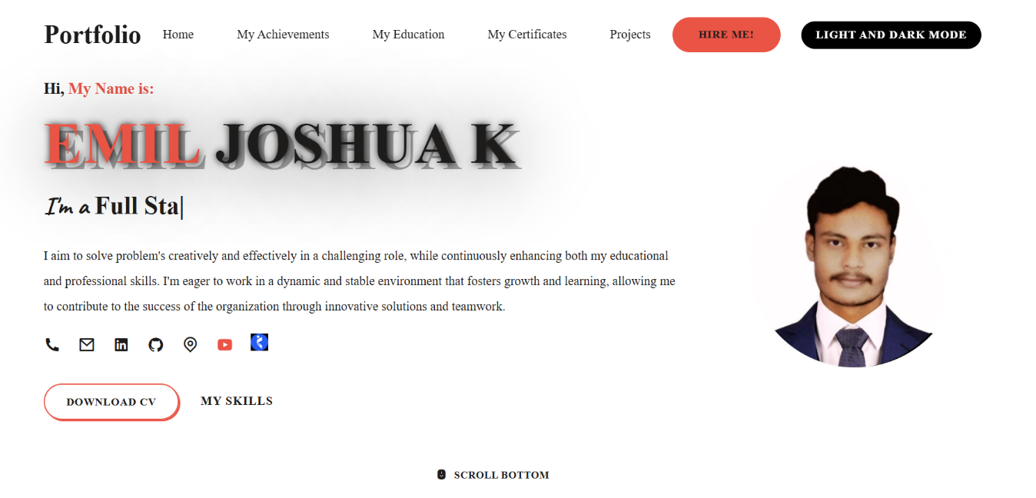

Fig 1.1.1 shows the icon of YouTube. When click on this, it will automatically open the YouTube video.

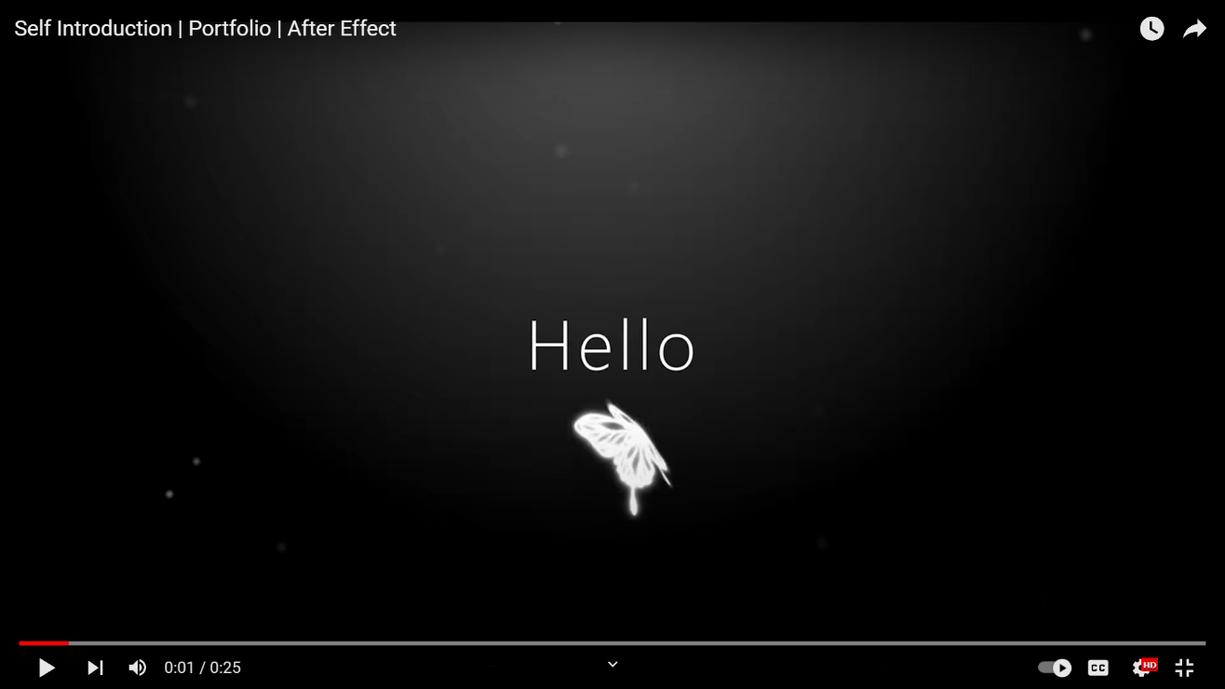

Fig 1.1.2 Displays the YouTube video of self-introduction.

# Chapter 2

## Website Bio Score:

* 1. **Description:**

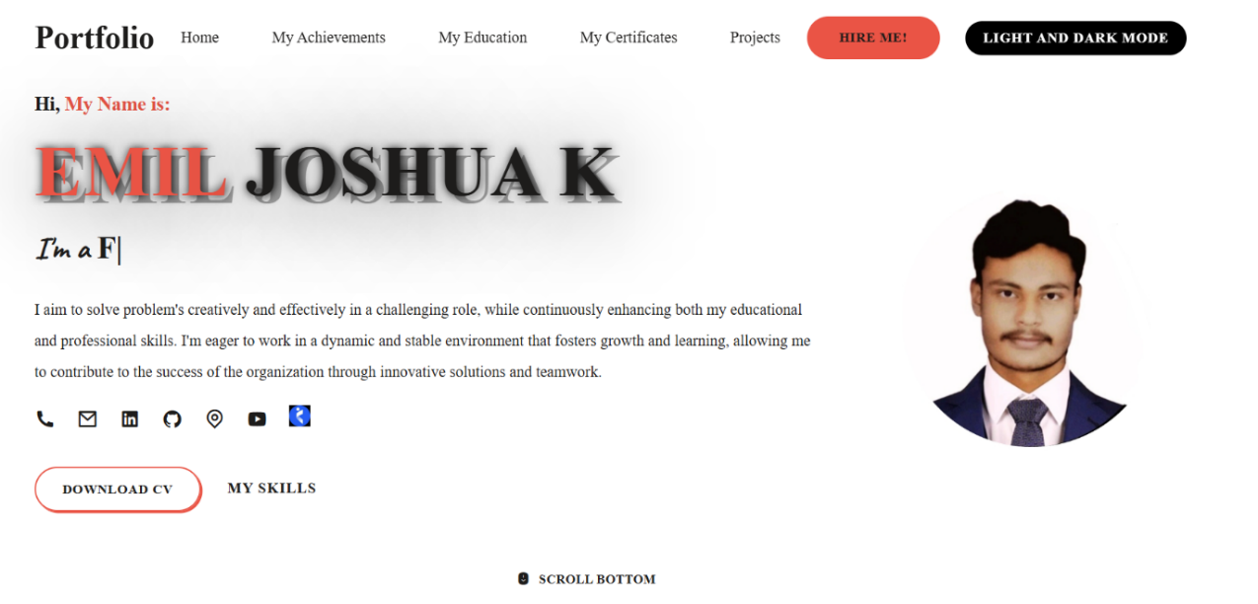

Fig 2.1.1 This shows that what I did in the portfolio project in one page.

* 1. **Contact Information (LinkedIn, GitHub, Email, Etc…..)**

**Description:** Contact Information refers to the details that allow someone to reach or communicate with a person or organization. It typically includes a Contact, Gmail, Linkedin, Github, Location, YouTube and Nakuri, This information is essential for facilitating communication or inquiries. Ref: Fig 2.1.2

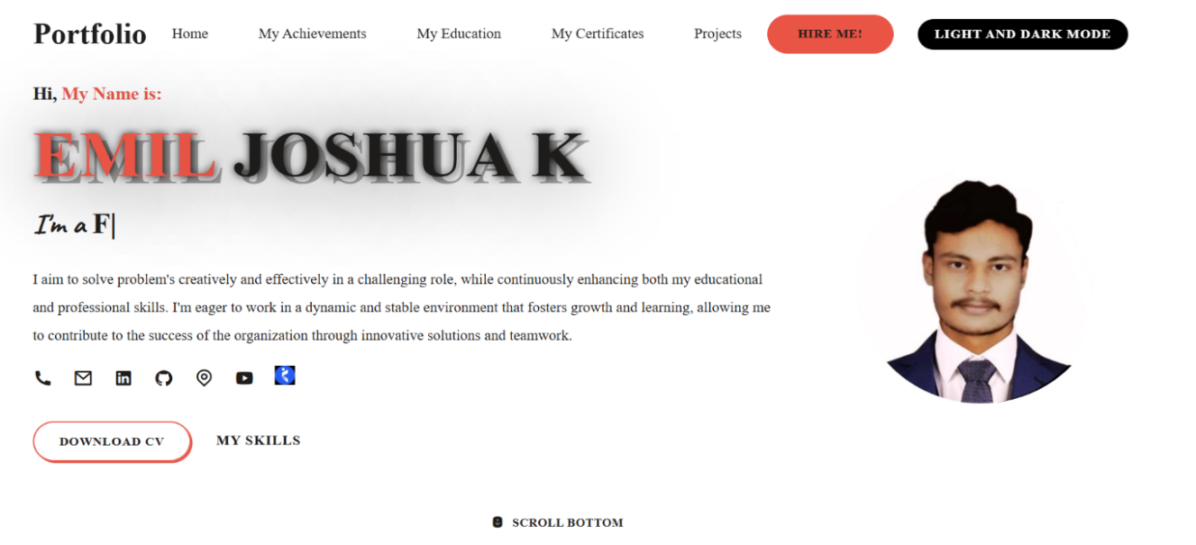

Fig 2.1.2 This shows the Contact, Gmail, Linkedin, Github, Location, YouTube and Nakuri links.

# Chapter 3

## Pages &amp; Navigation:

* 1. **Landing Page**

**Description**: A landing page is a standalone web page, created specifically for a

marketing or advertising campaign. It’s primary goal is to capture visitor information or prompt them to take a specific action, such as signing up for a service, making a purchase, or downloading content. Unlike other web pages, landing pages are focused and designed to convert visitors into leads or customers by minimizing distractions and presenting a clear call to action. Ref: Fig 3.1.1 and 3.1.2.

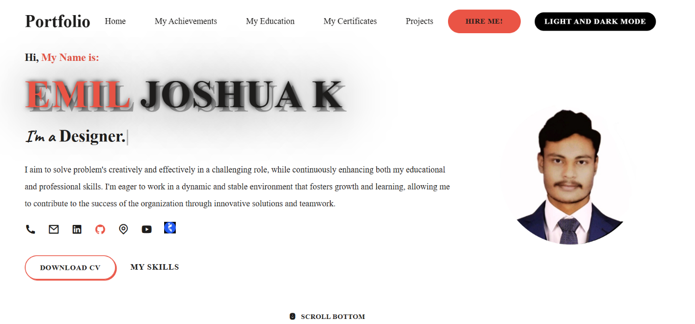

Fig 3.1.1 shows the Gmail, LinkedIn, GitHub, YouTube are in home page.

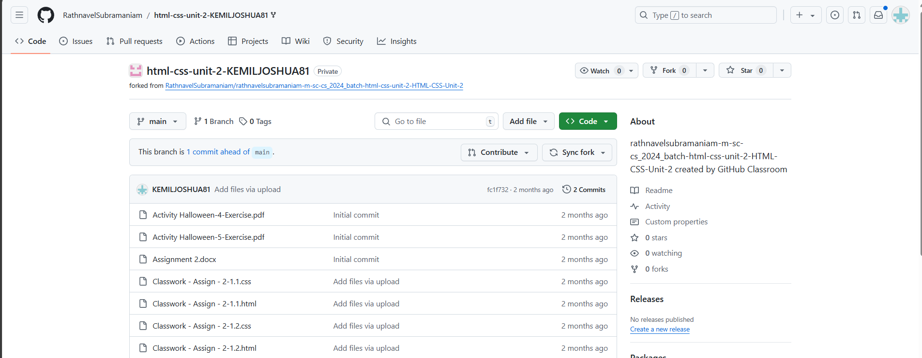

Fig 3.1.2 Displays the GitHub page when clicked on the GitHub icon it landed to GitHub page.

* 1. **Project Page**

**Description:** A **project page** is a web page or section of a website dedicated to showcasing a specific project. It typically includes key details such as the project’s goals, timeline, team members, progress, outcomes, and relevant media (images, videos, or documents). The page may also provide updates, resources, and links to related content, serving as a comprehensive overview or portfolio entry for the project.

Ref: Fig 3.2.1, Fig 3.2.2, Fig 3.2.3, Fig 3.2.4. (As Mobile View) 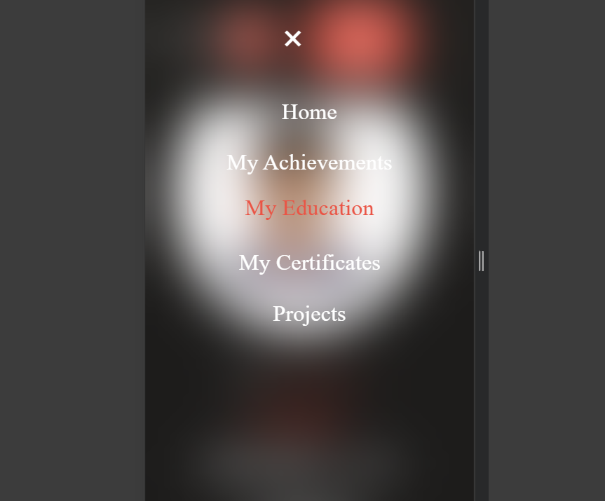

Fig 3.2.1 Shows the Navigation Page for Project. (Mobile View)

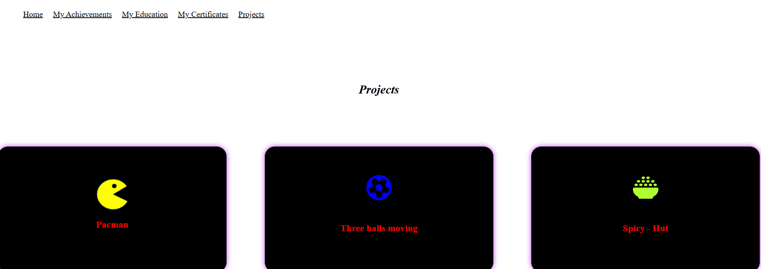

Fig 3.2.2 displays Project Page.

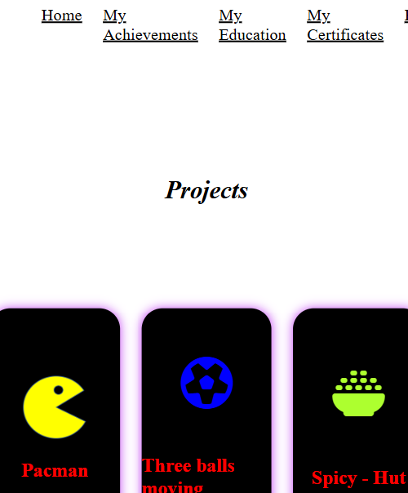Fig 3.2.3 By clicking the Project we can see the Project (Mobile View)

## 

Fig 3.2.4 Displays the project Pacman, When we used to click on the project. (Mobile View)

* 1. **Navigation Bar**

**Description:** A **navigation bar** (or **navbar**) is a user interface element on a website or application that provides links to important sections or pages. It is typically displayed as a horizontal or vertical menu at the top or side of a page, allowing users to easily navigate through the site’s content. The navigation bar often includes links such as "Home", "Achievement", "Education", "Certificate", “Project” and other key sections, enhancing the user experience by improving accessibility and organization.

Ref: Fig 3.3.1 and Fig: 3.3.2 (As Mobile View). Fig 3.3.1 shows the navigation bar for home, achievement, education, certificate and project.(Mobile View)



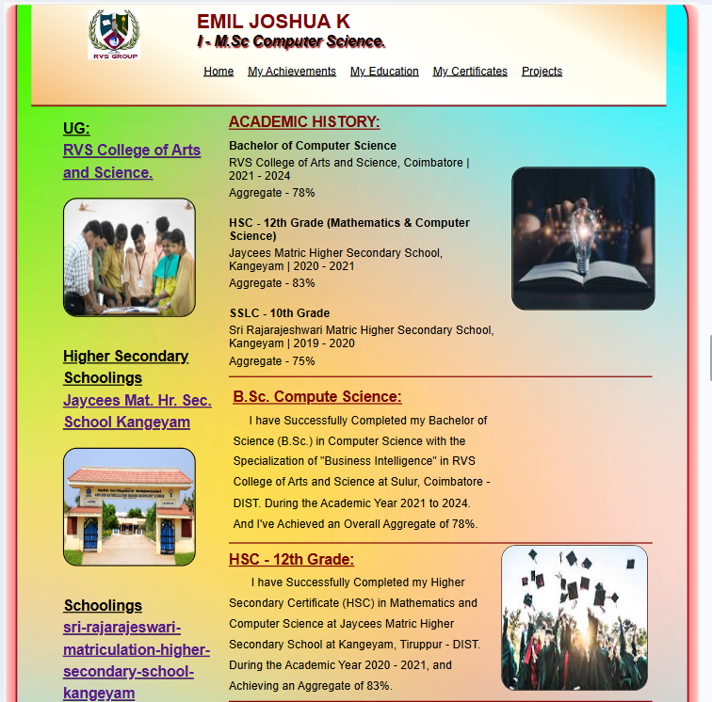

Fig 3.3.2 Displays the Navigation Bar in Mobile Compact Mode. (Mobile View)

# Chapter 4

## Styles Score:

* 1. **Styles (Font Color Images)**

**Description: Styles** in web design or programming refer to the set of rules and properties used to control the appearance and layout of elements on a webpage or application. Styles define how text, images, and other components are displayed, including aspects like font size, color, margins, spacing, borders, and alignment. These are usually managed through CSS (Cascading Style Sheets) in web development, enabling designers to create visually appealing and consistent designs across different pages or platforms. Styles help enhance user experience by making content more organized and aesthetically pleasing. Ref: Fig 4.1.1 and 4.1.2.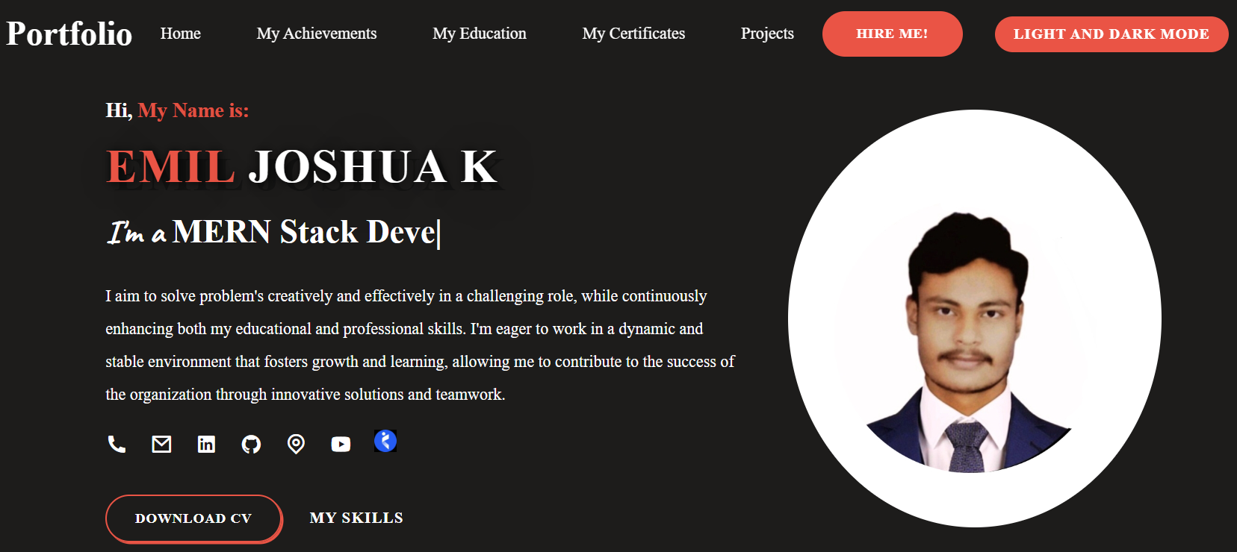Fig 4.1.1 To shows the color styles marked has Orange.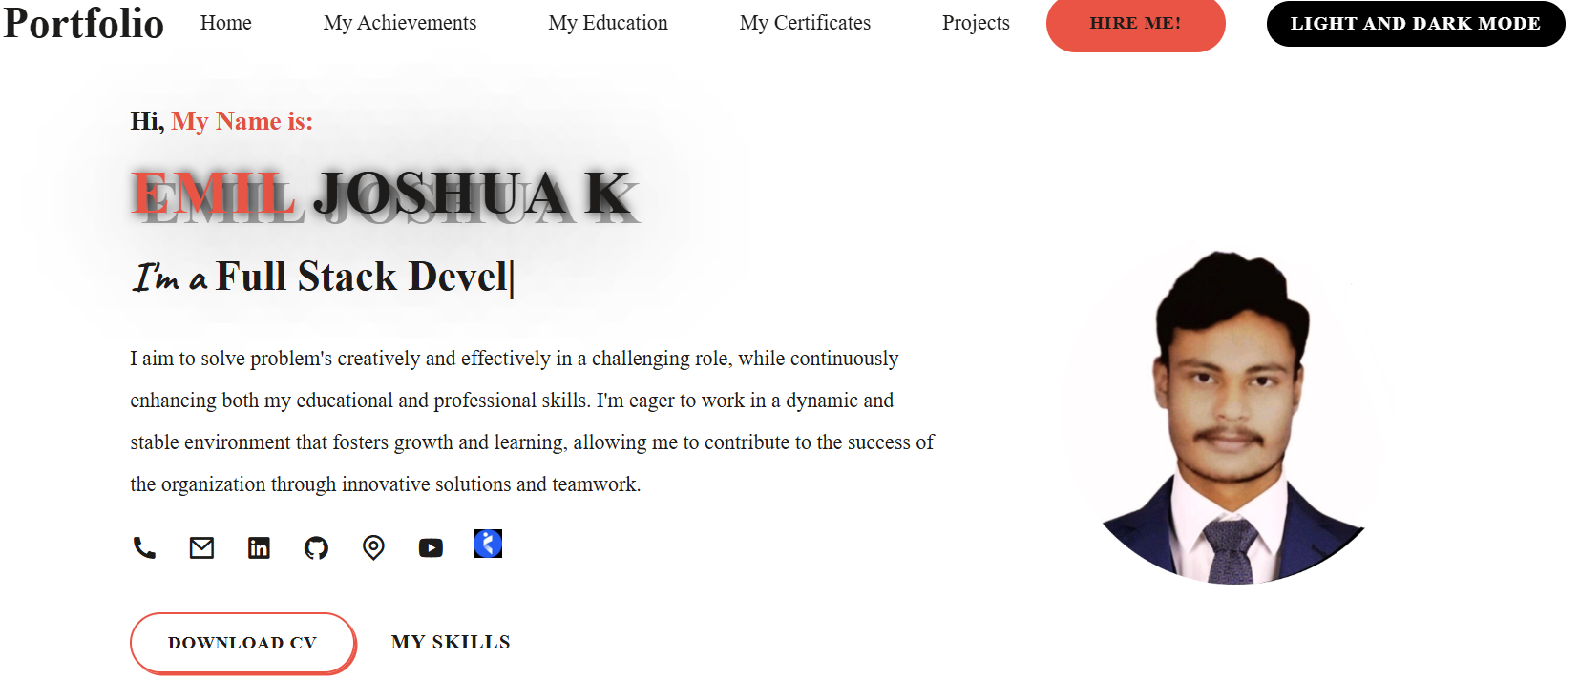Fig 4.1.2 To shows the color styles marked has Light and Dark Mode.

* 1. **Styles Link (Link in Blue color &amp; Underline Navigation):**

**Description:** A **styles link** refers to an HTML element (<link>) that connects a webpage to an external stylesheet (usually a CSS file). This link enables the webpage to apply styles such as fonts, colors, layouts, and spacing as defined in the CSS file. By using a styles link, developers can manage the design and presentation of multiple web pages from a single stylesheet, ensuring consistency and simplifying updates. Ref: Fig 4.2.1.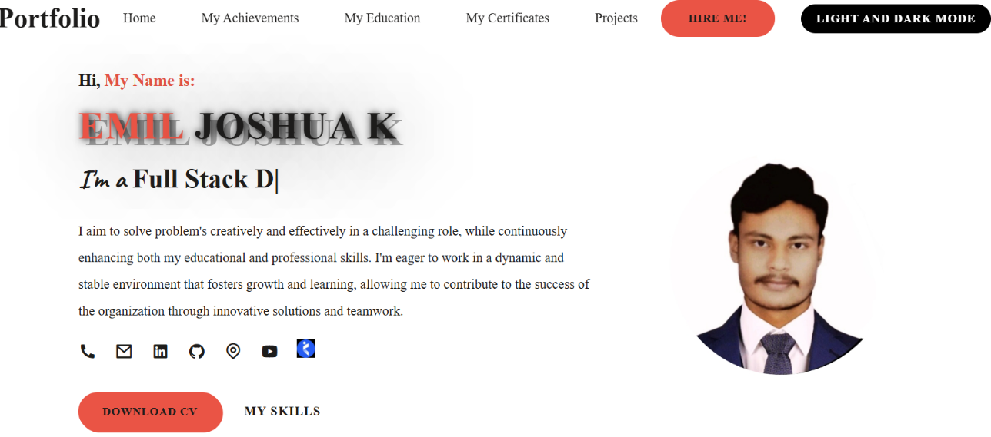

Fig 4.2.1 Shows the Home Page. In this page the style link Download CV visit to resume.

* 1. **Use of Grid Layout:**

**Description:** Grid Layout excels at dividing a page into major regions or defining the relationship in terms of size, position, and layer, between parts of a control built from HTML primitives. Ref: Fig 4.3.1.

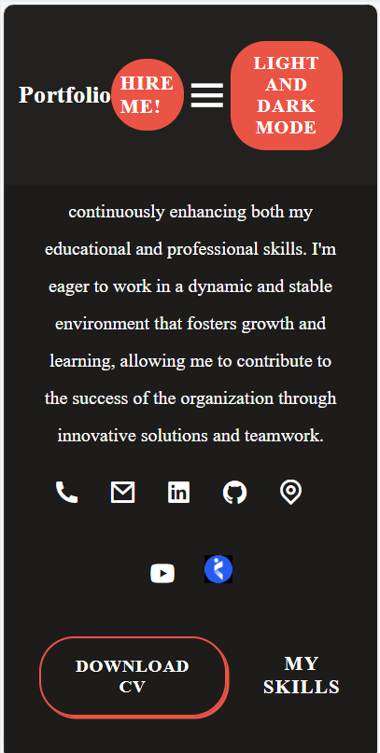

Fig 4.3.1 Shows the “Grid Layout”. In this, Page the Navigation Bar shows the Gird Layout form.

# Chapter 5

## Website Include the Following Information:

* 1. **Project Links to GitHub**

**Description**: Project links to GitHub refer to URLs or hyperlinks that direct users to a specific project repository hosted on GitHub. These links provide access to the project's code, documentation, and related files, allowing others to view, download, or contribute to the project. GitHub project links are commonly shared in portfolios, resumes, websites, or within collaborative teams to showcase work or facilitate open-source contributions. I Paste the link of my GitHub id in the hyperlink that turns this into a clickable link that will take me to my GitHub page. Ref: Fig 5.1.1 and 5.1.2.

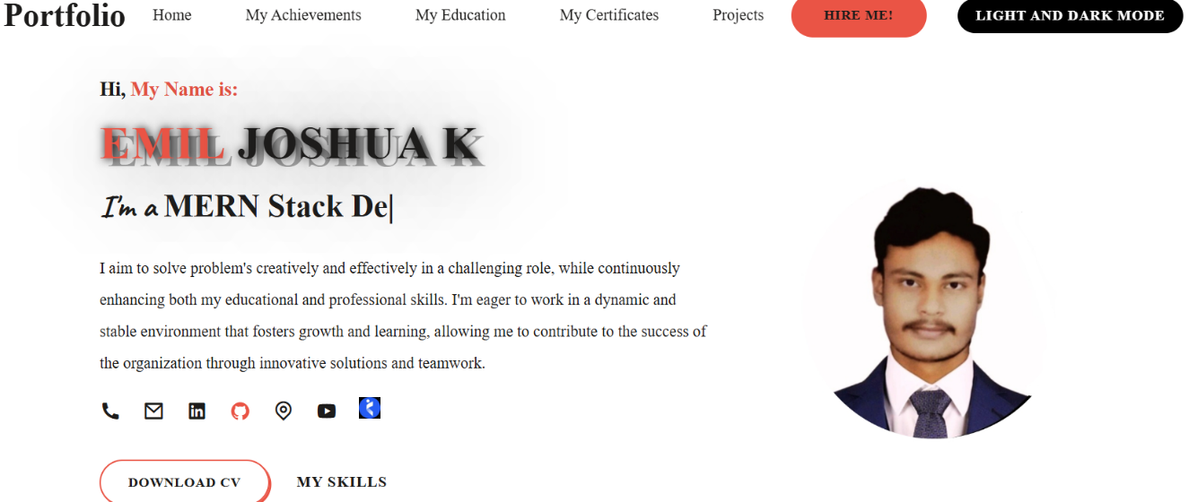

Fig 5.1.1 shows the GitHub icon in the home page. Clicking on this icon will take to my GitHub page.

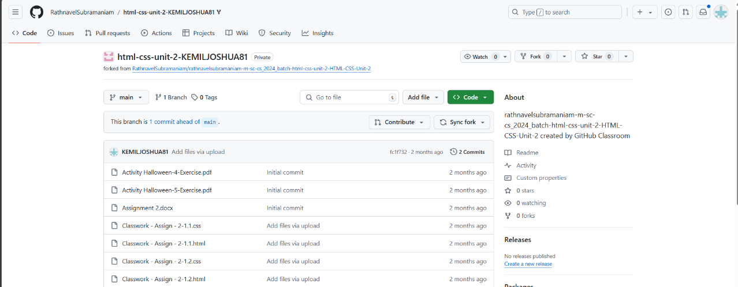

Fig 5.1.2 displays the GitHub page when clicked on the GitHub icon it landed to GitHub page.

* 1. **Project**



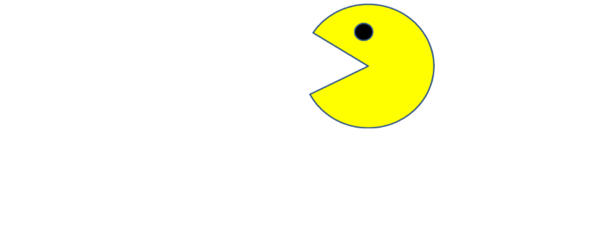

Fig 5.2.1 shows my first project in Portfolio. This project naming as Pacman. This project combined as html and JS code. (Mobile View)

Other projects are implemented in future.

# Chapter 6

## Bootstrap:

**6.1. Uses Bootstrap**

**Description:** Bootstrap makes responsive web design a reality. It makes it possible for a web page or app to detect the visitor’s screen size and orientation and automatically adapt the display accordingly.

* Bootstrap’s responsive CSS adjust to phones, tablets, and desktops. Mobile-first styles are part of the framework.
* Bootstrap is easy to set up and create a working layout in less than an hour.

# Chapter 7

## Project README:

* 1. **Title Description (Min 20 words)**

**Description:** Portfolios include information about who you are and examples of your work and achievements. A traditional resume is included in a career portfolio along with written and /or visual information that highlights what you have to offer.

* 1. **How to Run Project**

**Description:** To bring up the Run and Debug view, select the Run and Debug icon in the Activity bar of the side of VS code. You can also use the keyboard shortcut Ctrl+ Shift+ D.

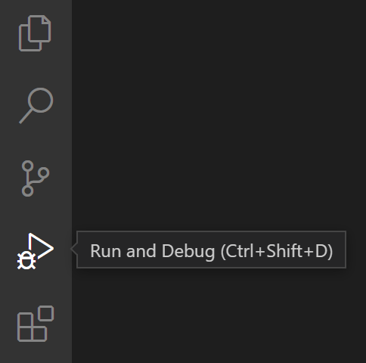

The **Run and Debug** view displays all information related to running and debugging and has a top bar with debugging commands and configuration settings.

If running and debugging is not yet configured (no launch.json has been created), VS Code shows the Run start view.

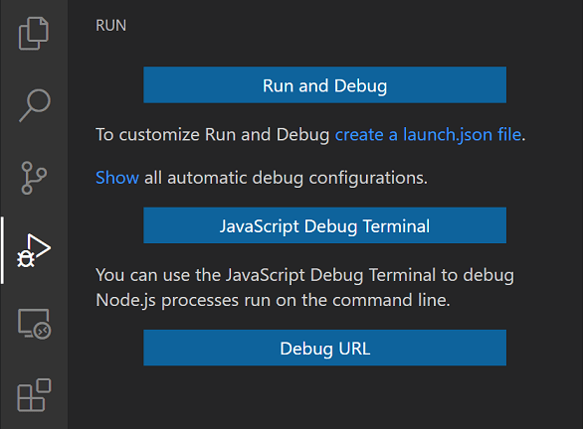

[**Run menu**](https://code.visualstudio.com/docs/editor/debugging#_run-menu)

The top-level **Run** menu has the most common run and debug commands:

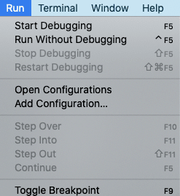

## Additional:

The another one way to run the project is copy the project path and paste on the chrome, Firefox to run.

## Run mode

In addition to debugging a program, VS Code supports **running** the program.

The **Debug: Run (Start without Debugging)** action is triggered with Ctrl+F5 and uses the currently selected launch configuration. Many of the launch configuration attributes are supported in 'Run' mode. VS Code maintains a debug session while the program is running, and pressing the **Stop** button terminates the program.

**Tip:** The **Run** action is always available, but not all debugger extensions support 'Run'. In this case, 'Run' will be the same as 'Debug'.

## Future improvements of projects:

**Description:** Portfolio and about page is my future implementation of my portfolio

project.

# Chapter 8

## File structure:

**8.1. GitHub file structure**



Fig8.1.1displaysrepositoriesintheGitHubpage**.**byclicking anyoftherepositorieswillnavigatetotheprojectinsidethelink**.**

# Html coding:

# 

# 

# 

# 

# 

# CSS coding:

# 

# 

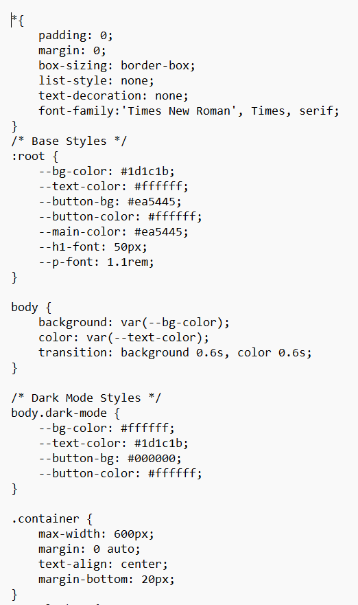

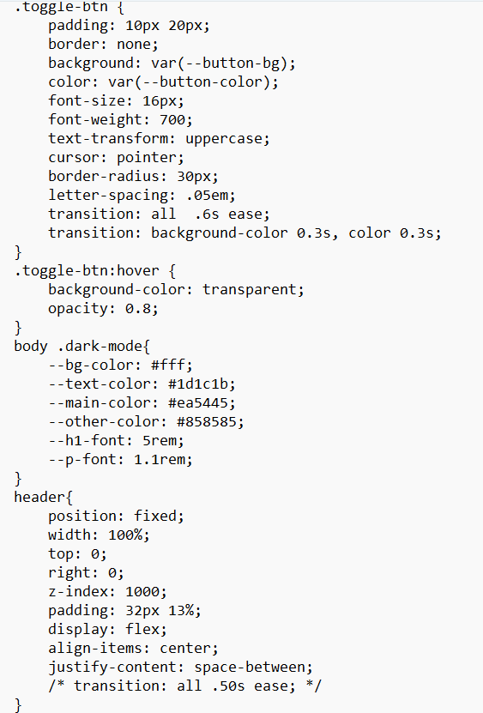

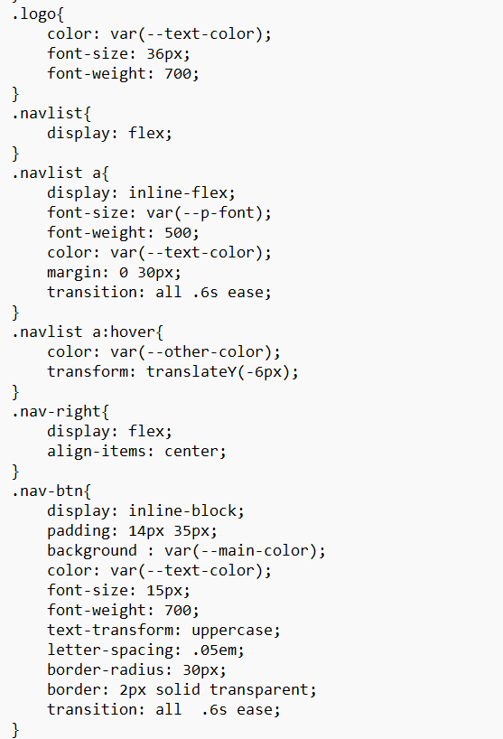

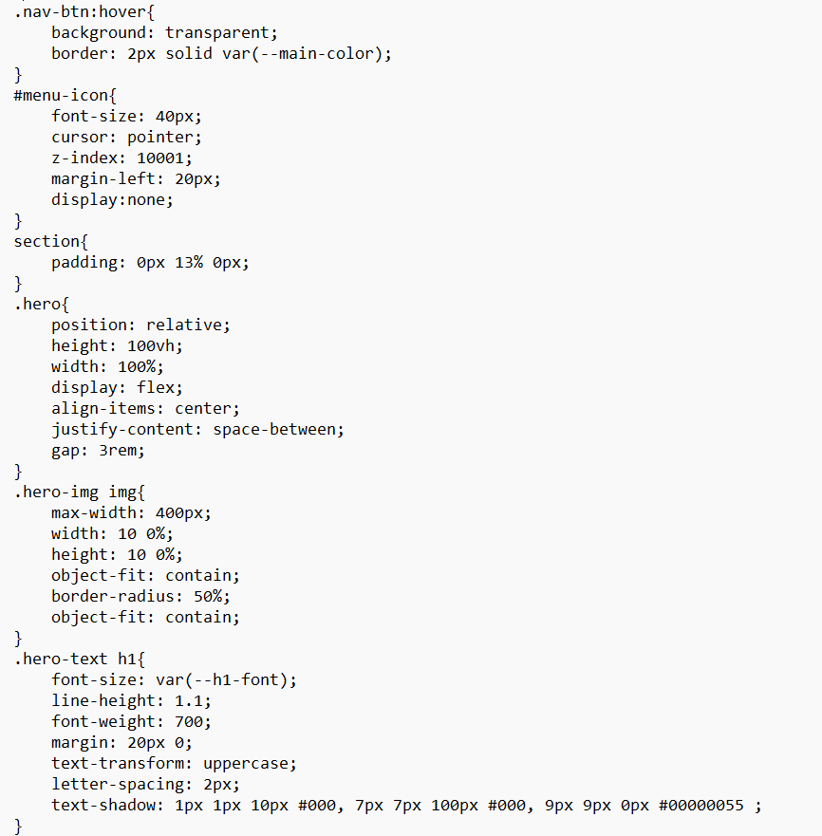

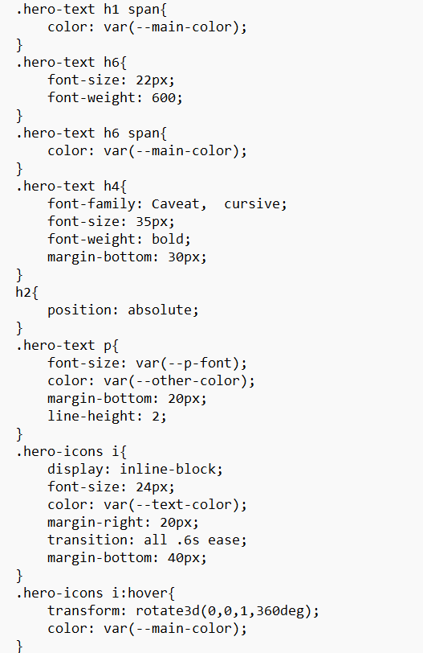

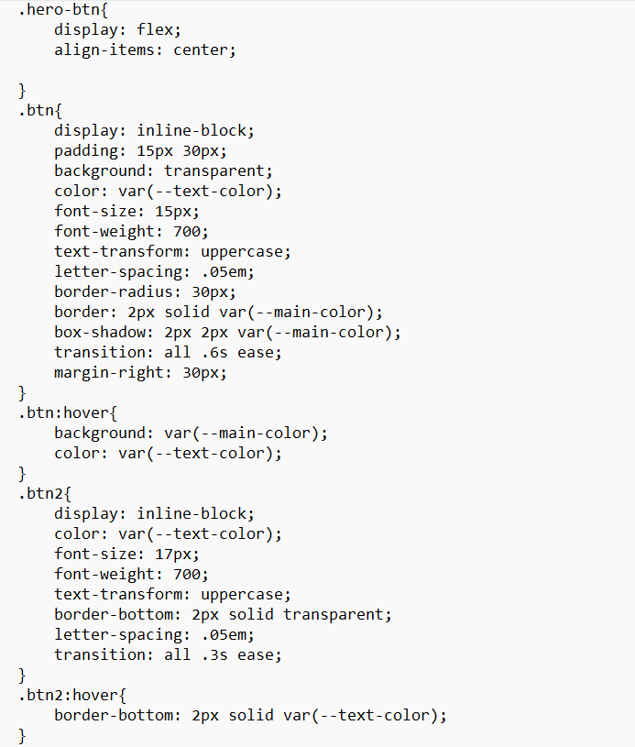

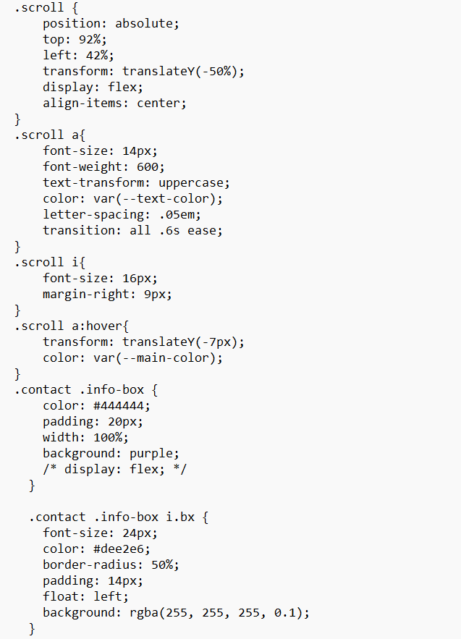

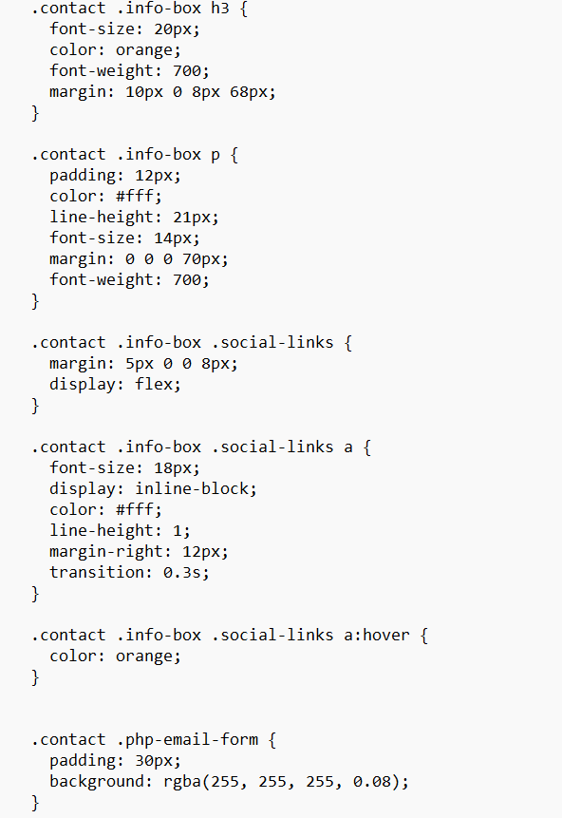

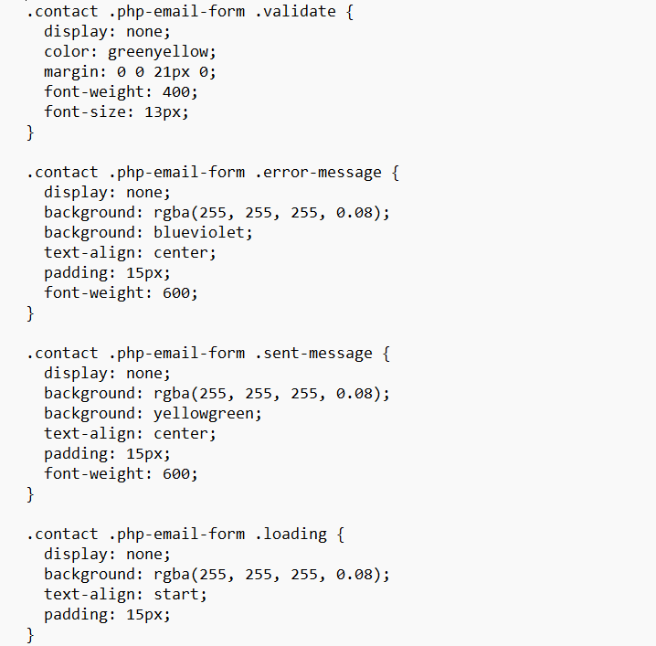

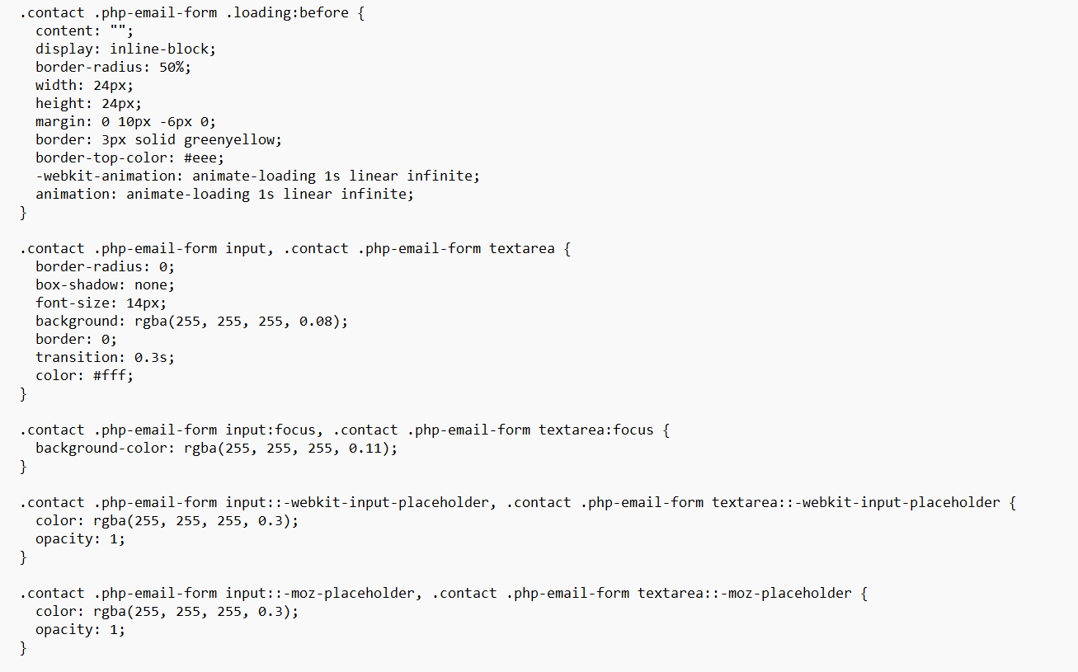

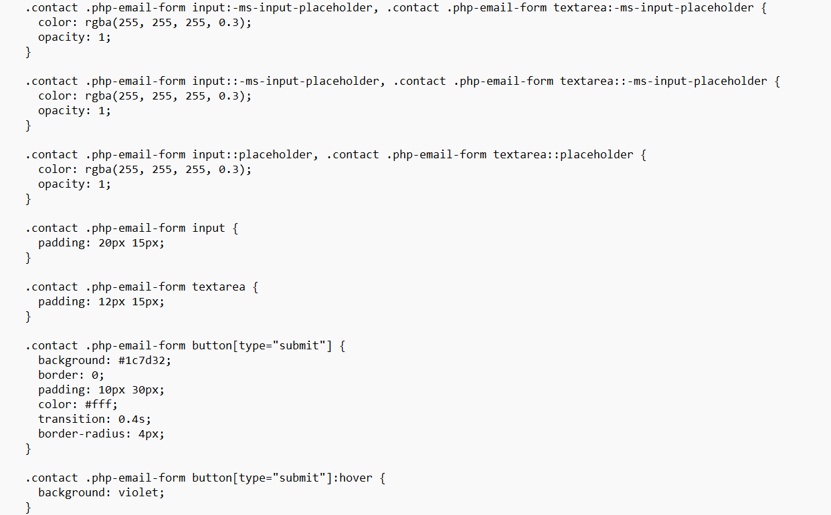

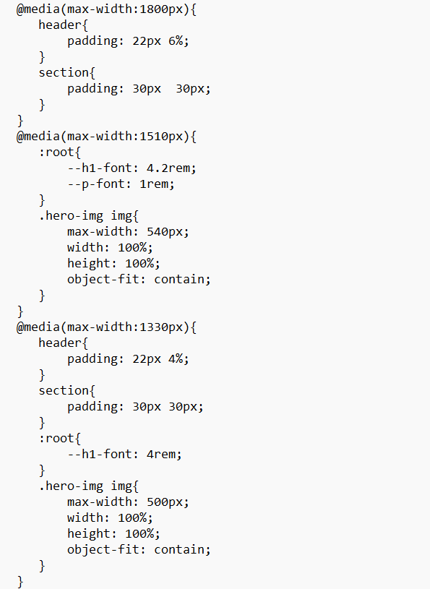

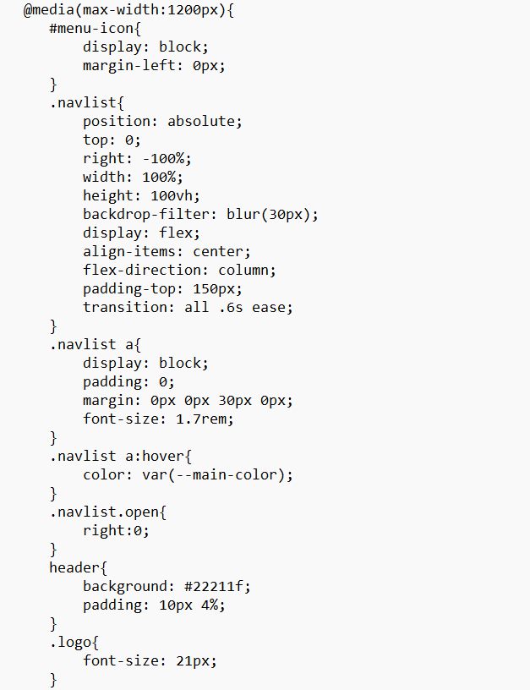

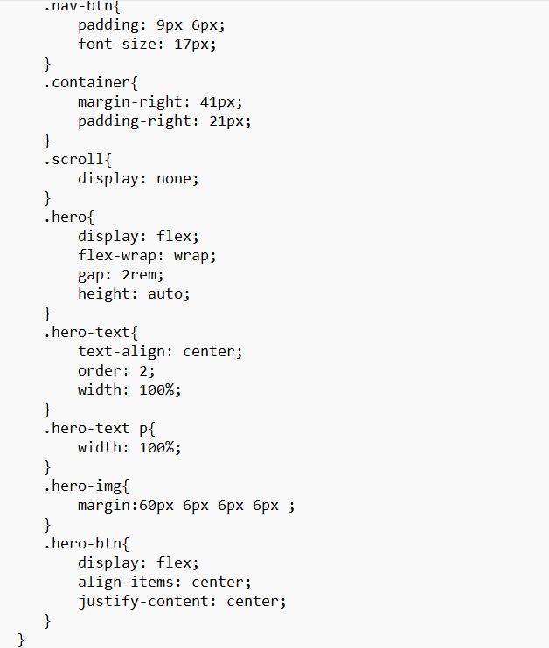

# JS coding:

